COMPUTATIONAL STUDY OF A HOST- GUEST INTERACTION BETWEEN POLYAMINE LIGANDS AND METAL IONS

Keywords: Computational Chemistry, Host-Guest Study

M.CS. Rodrigo Rodolfo González Jiménez
RRGonzalezJimenez@gmail.com
pigoyoyo@hotmail.com

ABSTRACT
The present work shows a computational study of a host-guest interaction between the ligands: Compounds I (2,9-di(2-methylamino-ethyleneamine)-1,10-phenanthroline), Compound II (2,9-di (3 -methylamino-propylamine)-1,10-phenanthroline.) and the metal ions Cu (II) and Zn (II). With the help of a software (Hiperchem 8) Compounds I, II were drawn, the optimal geometries were obtained, and a semi-empirical method (Polak Ribiere) was applied. Total Energies of Compounds I, II and binding energies were obtained.

INTRODUCTION
In a compound, the attractive force between atoms is called a chemical bond and they are classified depending on their nature, they can give up or share electrons. But there are other types of forces that make use of intermolecular interactions (Van der Waals force, hydrogen bonds, π interactions, ion+-π interactions) (1), these forces are responsible for molecular recognition that gives rise to another field of chemistry calledsupramolecular. The concept of supramolecular chemistry was introduced in 1978 by Lehn (2), where chemical species remain organized through non-covalent interactions, its field of action was extended to the identification of molecular recognition and the study of intermolecular interactions with the participation of organic and inorganic species (3) In this way the chemistry of molecular recognition became the essential part of “host-guest” chemistry⁽⁴⁾. Supramolecular species are characterized by the spatial arrangement of their components, architecture and by the nature of intermolecular bonds, which vary in strength, direction and angles to obtain interactions in various positions, there must be characteristics in terms of their shape, size , interaction sites, bond strength and affinity (5). These interactions provide the specificity and stability of the host-guest association. In general, macrocyclic structures meet these requirements, they are suitable for the construction of molecules that contain the cavities or cracks that provide the appropriate structure for the arrangement of binding sites, reactive groups and binding species. Among the best known macrocyclic receptors, we have the coronandos, sferandos, clatrochelates,
Similarly, scientists have incorporated aromatic units into polyamine molecules capable of generating enough space to incorporate metal ions and preserve their coordinating properties, eg 1,10-phenanthroline. This rigid unit provides aromatic nitrogens, directed in such a way that they act cooperatively in bonding with a metal ion; providing photophysical and photochemical characteristics to the compounds.(10) Hence, a computational theoretical study was made with similar chemical structures such as Compounds I (2,9-di(2-methylamino-ethyleneamine)-1,10-phenanthroline ) and II (2,9-di (3-methylamino-propylamine)-1,10-phenanthroline.), simulating its interaction with the metal ions Cu (II) and Zn (II). With the help of a software in computational chemistry (10) that is based on laws of classical and quantum physics where complex equations such as Schrodinger's are solved. The computer programs contain a basic set of tools such as Structure Optimization, Ab initio, Density Functional Method, Semiempirical methods (11), allowing a practical solution to this equation and moderating different types of molecular interaction such as the one proposed.

METHODOLOGY
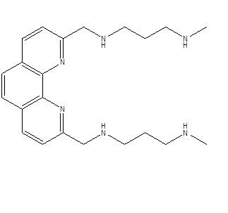
With the help of software (Hiperchem 8) Compounds I and II were drawn
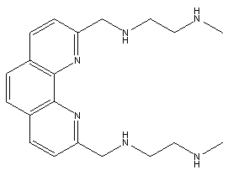

Compounds I (2,9-di(2-methylamino-ethylenamine)-1,10-phenanthroline), Compound II (2,9-di(3-methylamino-propylamine)-1,10-phenanthroline.) [13].

and obtained the optimal geometries. A log was generated and a semi-empirical method was applied to obtain the value of the total energy of each compound, this was the starting point for the host-guest interactions. The metal ion (Cu (II) and/or Zn (II)) that was bonded to the 2 nitrogens of the heteroaromatic group was drawn, a new log was generated applying a semi-empirical method, Polak Ribiere, PM3. We want to know the optimal geometries and energies all generated from the interaction of each binding site (nitrogens) with the metal ion, so it was necessary to repeat the calculation described, but interacting with 3, 4, 5 and 6 nitrogens belonging to the chains polyamines.

RESULTS
The Table 1 is the list of the total energies obtained in the calculation for Compound I and II when coordinating with Cu (II). For its part, Table 2 contains the total energies of Compound I and II.
Table 1. Total energy of Compound I and II (Cu (II)).
Compound I Total energy (Kcal/mol) | Compound II Total energy (Kcal/mol) | Link Nitrogens
-86634.11 | -93531.24 | Initial state
-113999.3 | -120897.18 | two
-114057.7 | -120918.27 | 3
-114058.62 | -120971.15 | 4
-114097.27 | -120991.31 | 5
-114070.1 | -120993.7 | 6

Table 2. Total energy of Compound I and II (Zn (II)).
Compound I Total energy (Kcal/mol) | Compound II Total energy (Kcal/mol) | Link Nitrogens
-86634.11 | -93531.24 | Initial state
-87312.66 | -94202.42 | two
-87341.1 | -94204.22 | 3
-87658.04 | -94262.77 | 4
-87353.28 | -94257.9 | 5
-87368.02 | -94263.61 | 6

Figures 2-6 represent Compounds I and 2 in 3D after having carried out the empirical, semi-empirical methods, optimal geometries with the help of the Hiperchem 8 program.
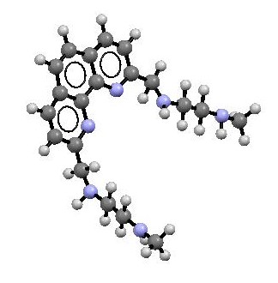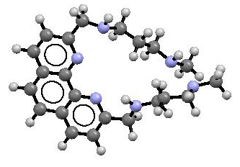
Figure 2. Compound I and II molecule optimized in Hiperchem 8 and photographed in Mercury 2.
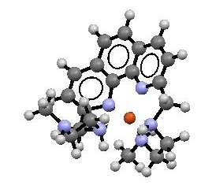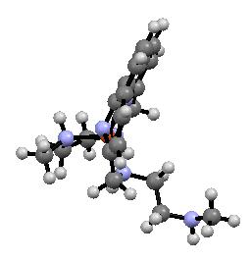
Figure 3. Compound I bound to Cu(II) as a host-guest system. Interaction optimized in Hiperchem 8 and imaged in Mercury 2.
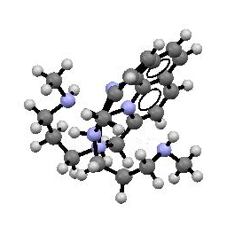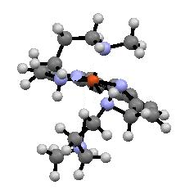
Figure 4. Compound II bound to Cu (II), optimized in Hiperchem 8 and photographed in Mercury.
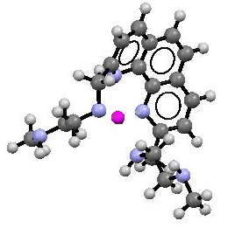
Figure 5. Compound I ligand with Zn (II). The molecule was optimized on Hiperchem 8 and imaged on Mercury.

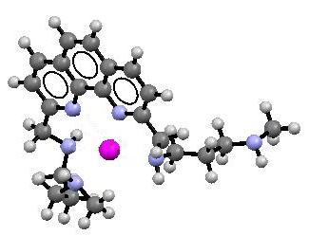

Figure 6. Compound II bound to Zn (II). The molecule was
optimized in Hiperchem 8 and photographed in Mercury.

DISCUSSION OF THE RESULTS
the data obtained from the interactions suggest that Compound I with Cu (II) its most stable state is with 5 of 6 nitrogens and Compound II is more stable with 6 nitrogens. Regarding the interactions with Zn (II), Compound I showed low energy or was more stable with 4 nitrogens. For its part, Compound II has 2 stable forms with 4 and 6 of its nitrogens.
This exercise shows how the use of the computer is a powerful tool for design, allowing us to model complex systems and save resources in the experimental part.
Thanks
I want to thank Angel and Johnny for all their support, my whole family AZ.

BIBLIOGRAFÍA
[1]. Francis A. Carey, 3ª edición, Química Orgánica. 60 -112, McGraw HILL interamericana de España S.A. u-. ISBN: 84,481-2426-X.
[2] Lehn, J. M. (1988). Supramolecular chemistry scope and perspectives molecules, supermolecules, and molecular devices (Nobel Lecture). Angewandte Chemie International Edition in English, 27(1), 89-112.
[3] Baron, R., & McCammon, J. A. (2013). Molecular recognition and ligand association. Annual review of physical chemistry, 64, 151-175.
[4] Lehn, J. M. (1995). Concept and perspectives. Supramolecular Chemistry.
[5] Lehn, J. M. (1973). Design of organic complexing agents strategies towards properties. In Alkali Metal Complexes with Organic Ligands (pp. 1-69). Springer, Berlin, Heidelberg.
[6] Pedersen, C. J. (1988). The discovery of crown ethers (Noble Lecture). Angewandte Chemie International Edition in English, 27(8), 1021-1027.
[7] Krische, M. J., & Lehn, J. M. (2000). The utilization of persistent H-bonding motifs in the self-assembly of supramolecular architectures. In Molecular Self-Assembly Organic Versus Inorganic Approaches (pp. 3-29). Springer, Berlin, Heidelberg.
[8] Gutsche, C. D. (2008). Calixarenes An introduction 2nd Edition.
[9] Rosete-Luna, S., Medrano, F., Bernal-Uruchurtu, M. I., & Godoy-Alcántar, C. (2009). Crown ether ditopic receptors for ammonium salts with high affinity for amino acid ester salts. Journal of the Mexican Chemical Society, 53(4), 209-219.
[10] Ahmed, M., Ward, S., McCann, M., Kavanagh, K., Heaney, F., Devereux, M., ... & Rooney, D. (2022). Synthesis and characterisation of phenanthroline-oxazine ligands and their Ag (I), Mn (II) and Cu (II) complexes and their evaluation as antibacterial agents. BioMetals, 1-13.
[11] HyperChem release 8.4 for windows molecular modeling. System
[12] Cuevas, G. (2003). Introducción a la química computacional. Fondo de cultura económica. [13] Mendoza, A., Aguilar, J., Basallote, M. G., Gil, L., Hernández, J. C., Máñez, M. A., ... & Verdejo, B. (2003). Hydrogen-ion driven molecular motions in Cu 2+-complexes of a ditopic phenanthrolinophane ligand. Chemical Communications, (24), 3032-3033.

